# TimedAudioExperimentOne instructions

**TimedAudioExperimentOne instructions** **1**

1. Download the ZIP file and move it into place 1

2. Open up "Terminal" utility 1

3. Go to the "dist" folder using "cd" - change directory 2

4. Run “java -jar TimedAudioExperimentOne.jar” 3

5. Enter the identifier 4

6. Use resources/TimedAudioExperimentOne_Config.xml to adjust configuration 4

7. Change the configuration file settings to adjust how it works. 6

8. Results stored in "ResultsFolder" location 7

9. View individual results files in Excel or any spreadsheet program 8

10. Quit using the red X or file menu 10

### 1. Download the ZIP file and move it into place

Download the ZIP file and move it into a place where you can use it, then expand it

(I'm moving it into a new folder called "beth_program" under Documents. You see it made a "dist" folder when it was expanded.)

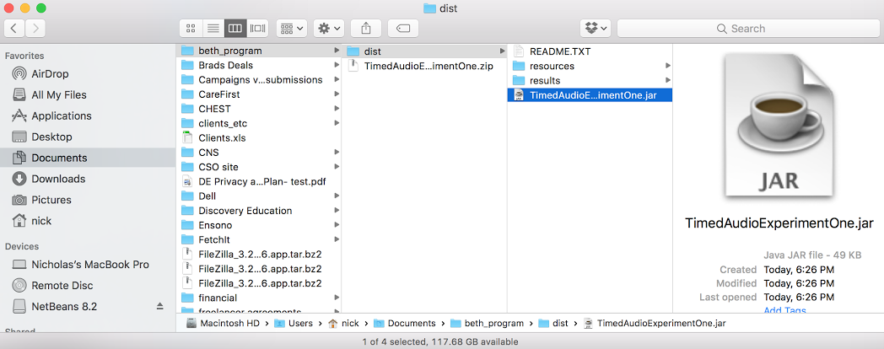

### 2. Open up "Terminal" utility

(I click on the magnifying glass in the upper right​ hand corner of the screen and type "terminal", then select it.

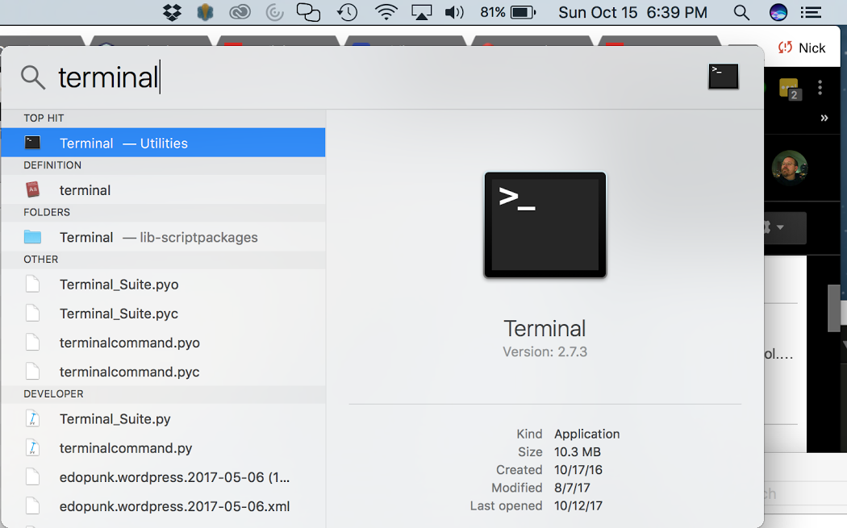

### 3. Go to the "dist" folder using "cd" - change directory

(for example "cd Documents/beth_program/dist/" and hit enter on my computer)

you can run "pwd" to "print out the working directory" to find out what folder you are in

you can run "ls" to get a "list" of what's in the folder

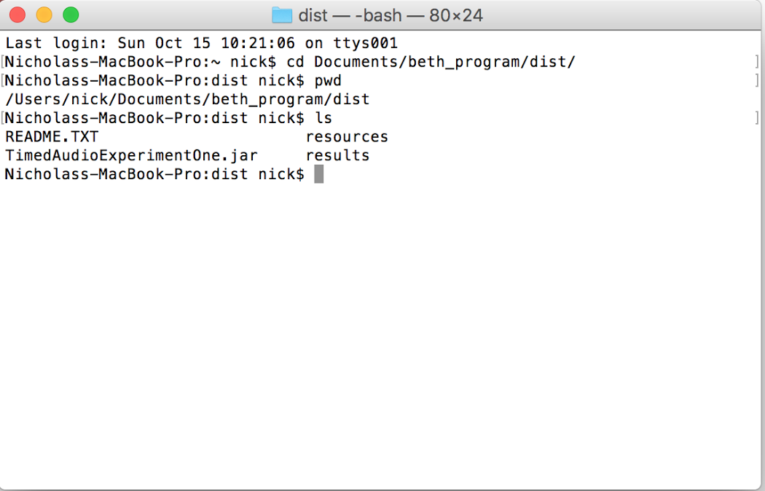

### 4. Run “java -jar TimedAudioExperimentOne.jar”

once you're in the folder where "TimedAudioExperimentOne.jar" is located, you start it by running

**java -jar TimedAudioExperimentOne.jar**

This will start the application.

The application will print out the current directory location and configuration settings in the Terminal, and request the Identifier of the participant. The application will continue to print out info while it's running.

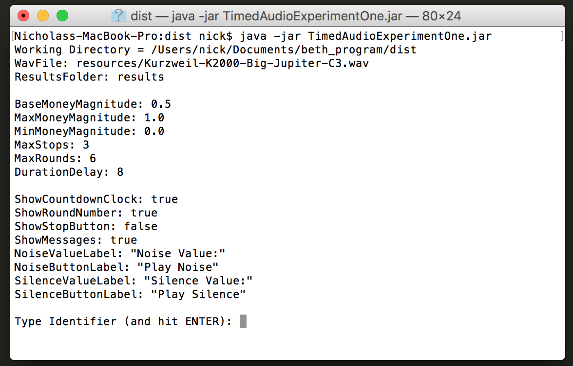

### 5. Enter the identifier

Once you enter an Identifier, the participant will be able to see the application screen.

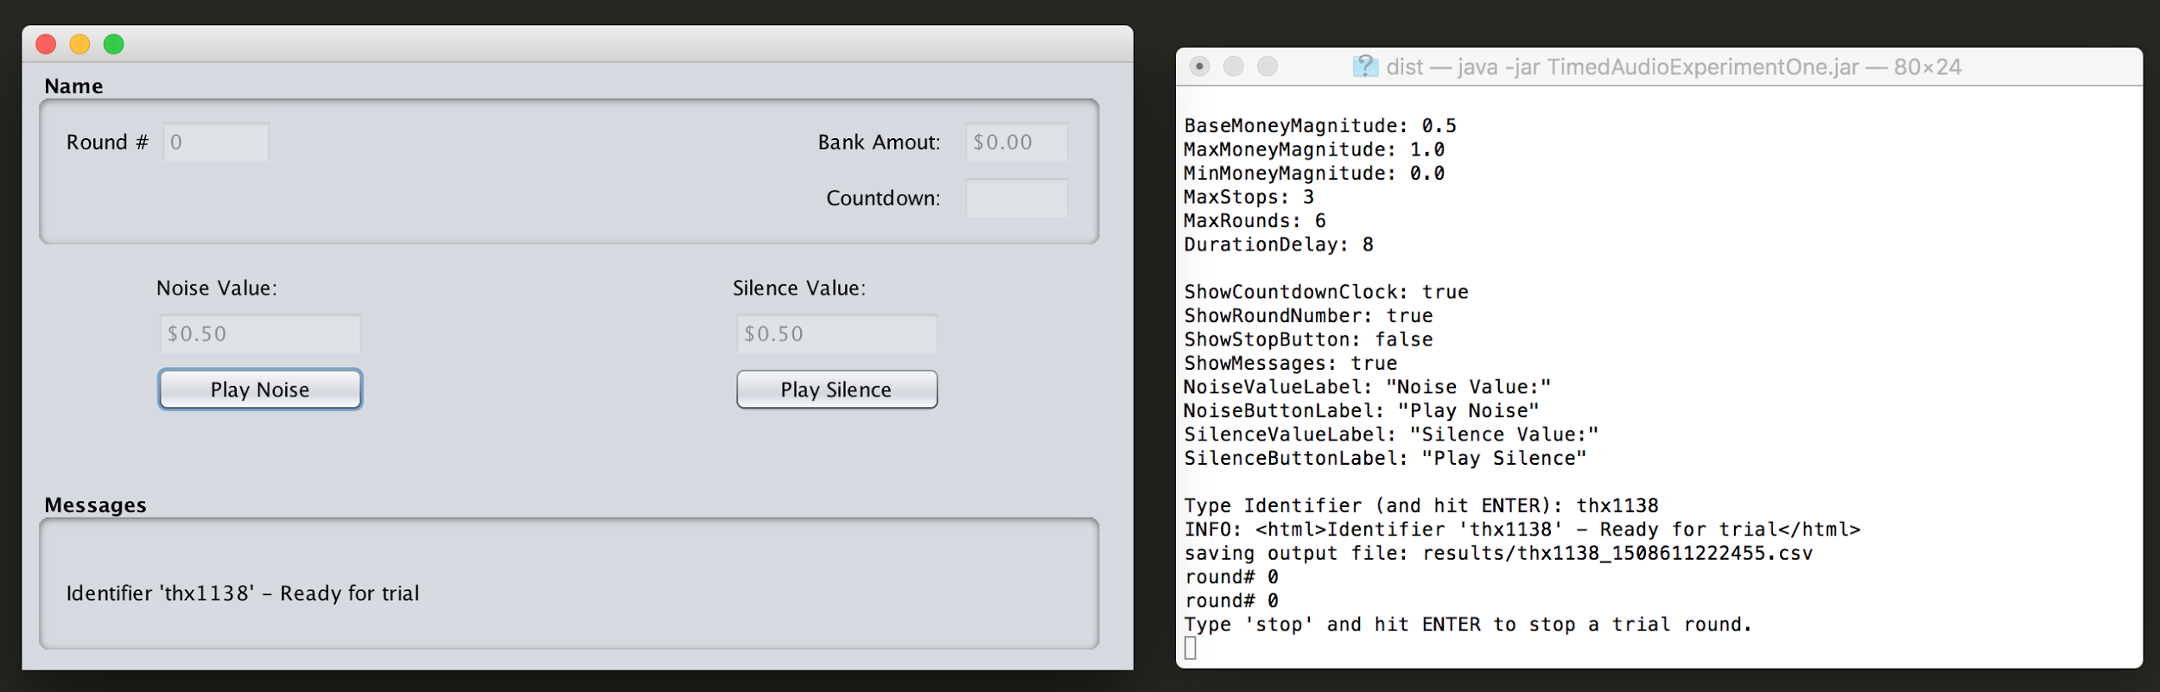

### 6. Use resources/TimedAudioExperimentOne_Config.xml to adjust configuration

**To change configuration, there is a file in the "resources" folder called "TimedAudioExperimentOne_Config.xml"**

Edit this file in a text editor like TextEdit.

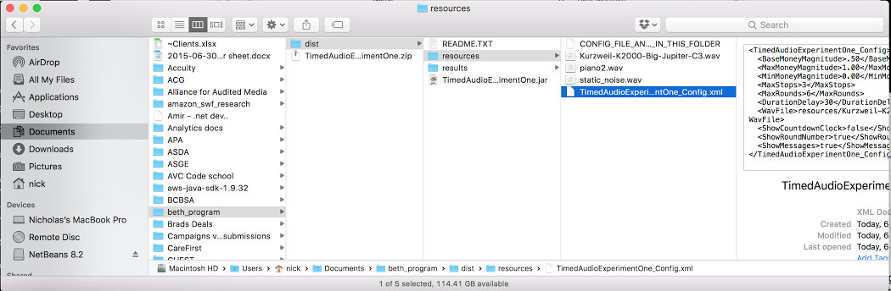

​You can find TextEdit the same way as you found Terminal

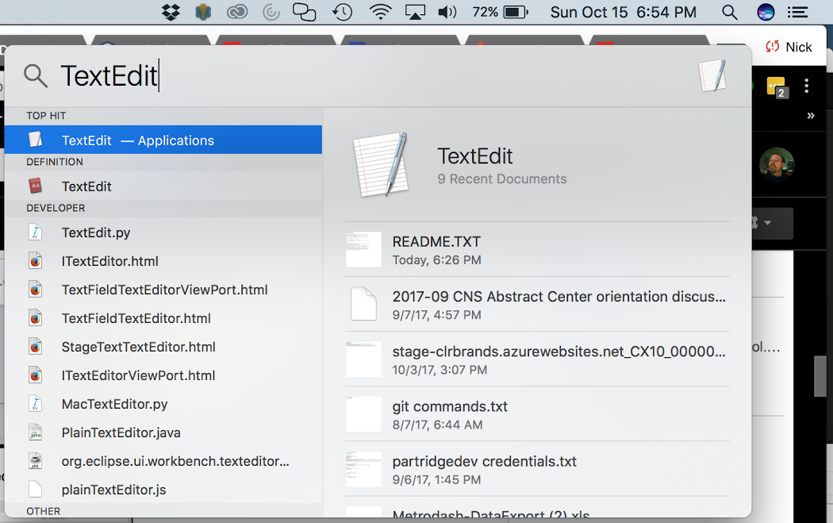

Or you can right-click (two-finger click) on the file in Finder and "Open With..."

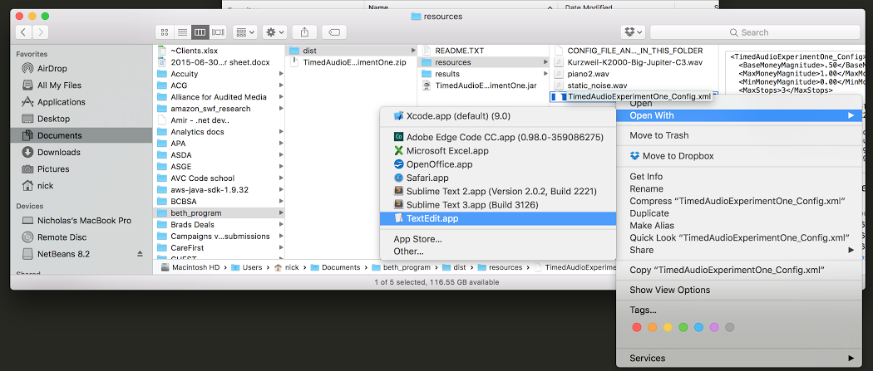

### 7. Change the configuration file settings to adjust how it works.

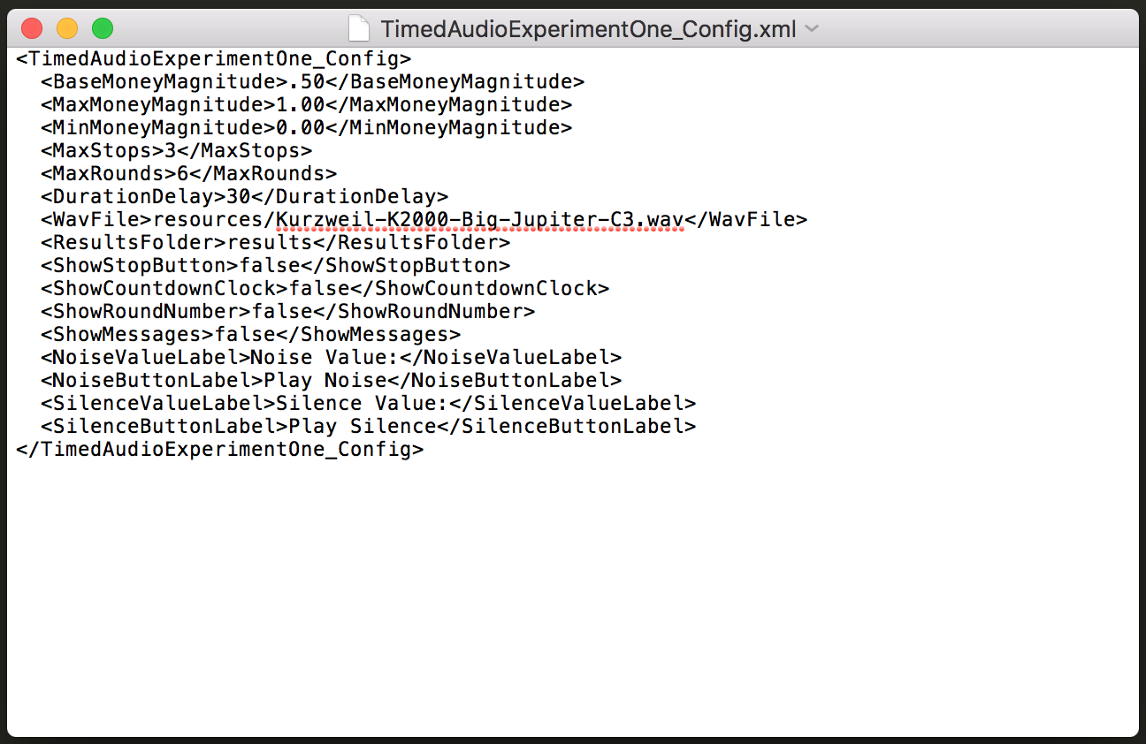

* "BaseMoneyMagnitude" - starting amount of money for each trial
* "MinMoneyMagnitude" - minimum amount of money
* "MaxMoneyMagnitude" - maximum amount of money
* "DurationDelay" - length of each trail
* "MaxStops" - number of times a participant is allowed to stop a trial
* "MaxRounds" - number of trials in a block, not including the initial test round
* "WavFile" - location of WAV audio file used for trials
* “ResultsFolder” - location where results will be stored
* “ShowStopButton” - show (true) or hide (false) a button to stop the current trial. Either way, you can type “stop” (and hit ENTER) in the Terminal
* "ShowCountdownClock" - show (true) or hide (false) a countdown clock on the screen
* "ShowRoundNumber" - show (true) or hide (false) display of the round number on the screen, will still appear in the terminal log
* "ShowMessages" - show (true) or hide (false) messages on the screen, will still appear in the terminal log
* “NoiseValueLabel” - label to display with the amount of money for playing sound
* “NoiseButtonLabel” - text to display on the button to play sound
* “SilenceValueLabel” - label to display with the amount of money for waiting in silence
* “SilenceButtonLabel” - text to display on the button to wait in silence

Here we’ve turned **off** all display options:

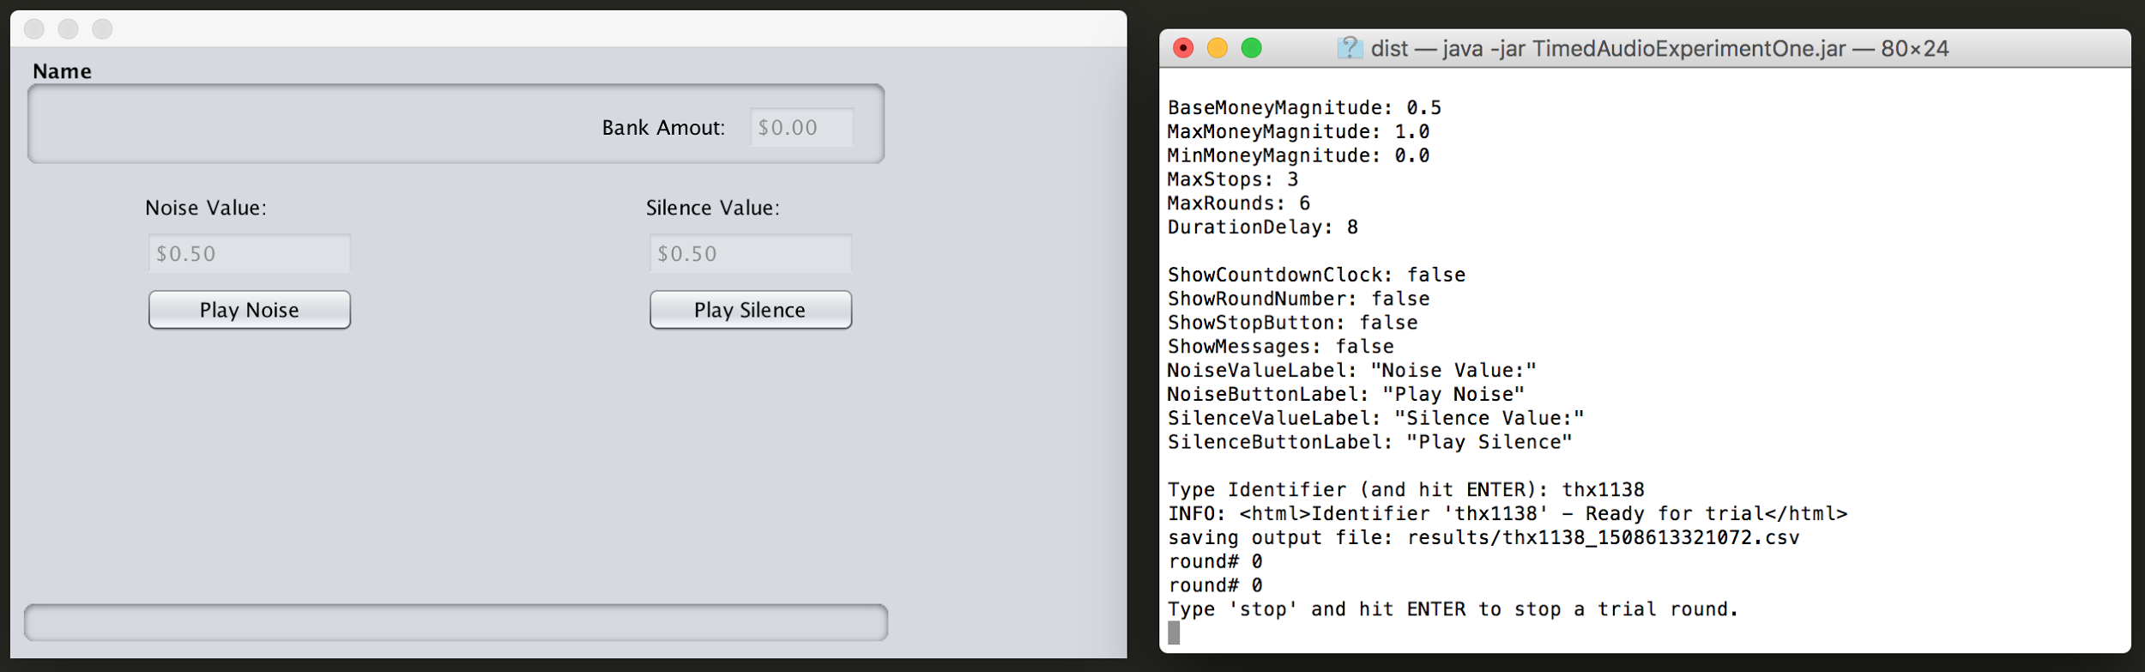

Here we’ve turned **on** all display options:

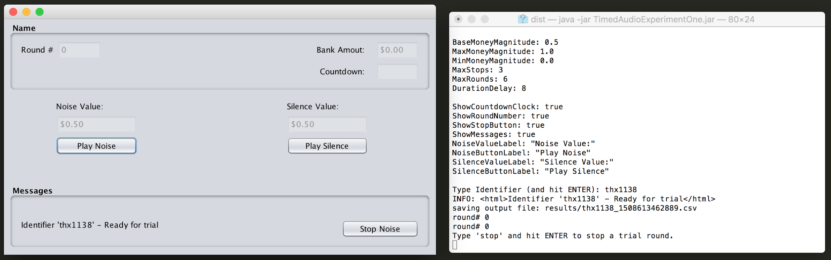

### 8. Results stored in "ResultsFolder" location

When you run the program, the results of each trial block will be stored in "CSV" files in the "ResultsFolder" location.

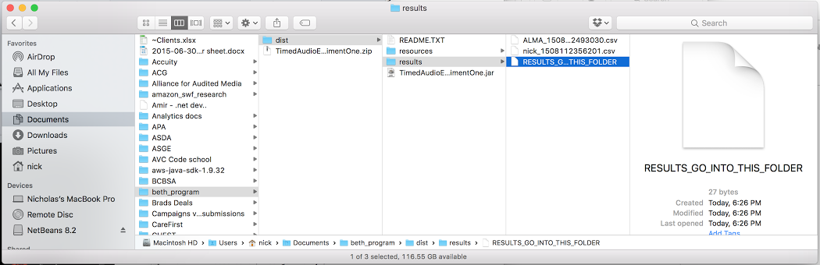

### 9. View individual results files in Excel or any spreadsheet program

CSV files can be viewed in Excel (or any spreadsheet program), but you will need to convert the money columns to currency.

In this screenshot, you can see I highlighted the column and there is a "money" button in the toolbar in the center of the screen.

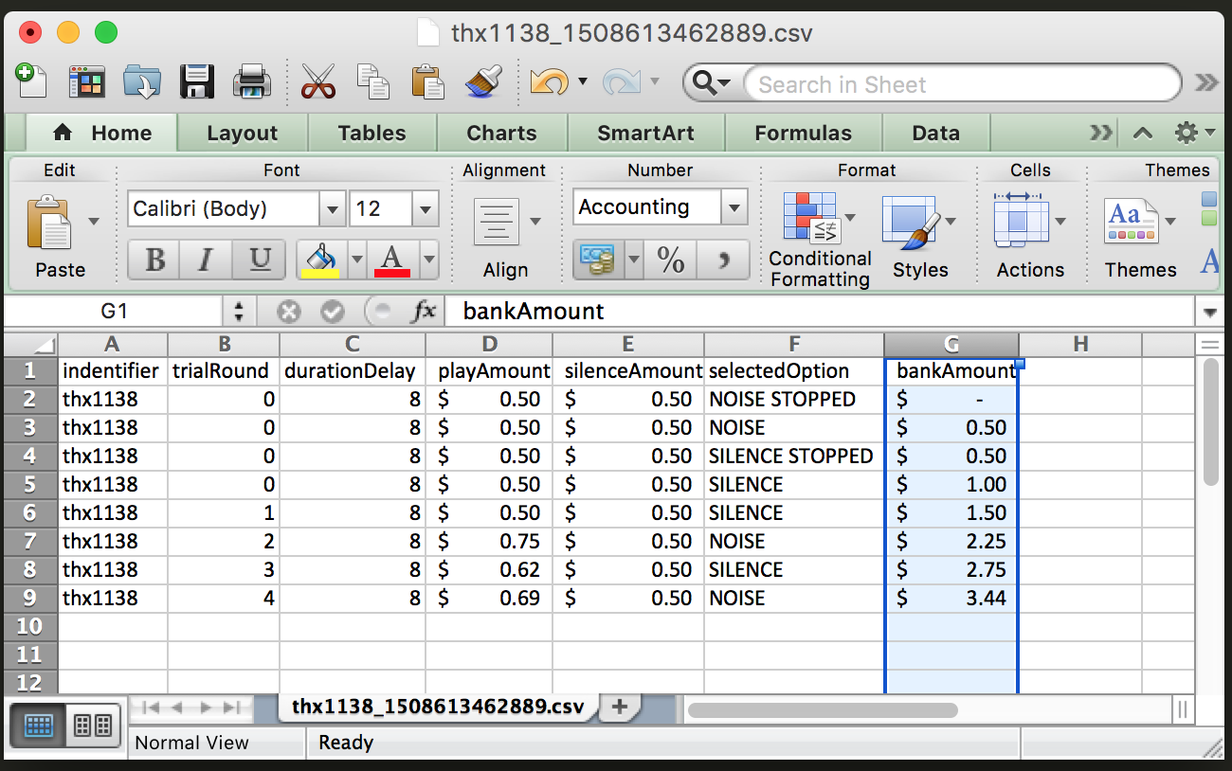

The program will also print out activity to the Terminal as it is running, even if you turn off "ShowMessages" in the configuration.

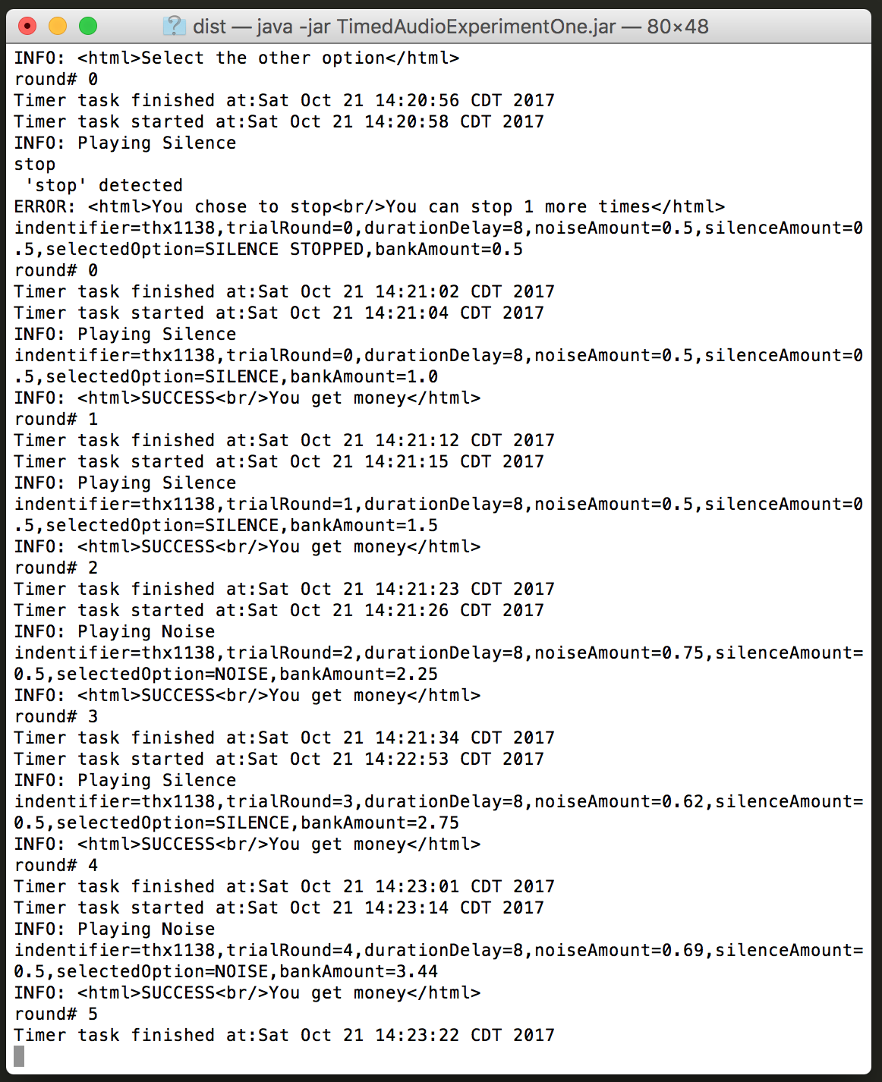

### 10. Quit using the red X or file menu

You can quit the app just as you would quit any other Mac app.

